

LAB NO :07

SUBJECT:
CLOUD COMPUTING.
SUBMITTED BY:
SABAHAT FATIMA.
SUBMITTED TO:
SIR SHOAIB.
ROLL NO:
2023-BSE-055.
DEPARTMENT:
SOFTWARE ENGINEERING.
SEMESTER:
5th

Task 1 – Print and Filter Environment Variables
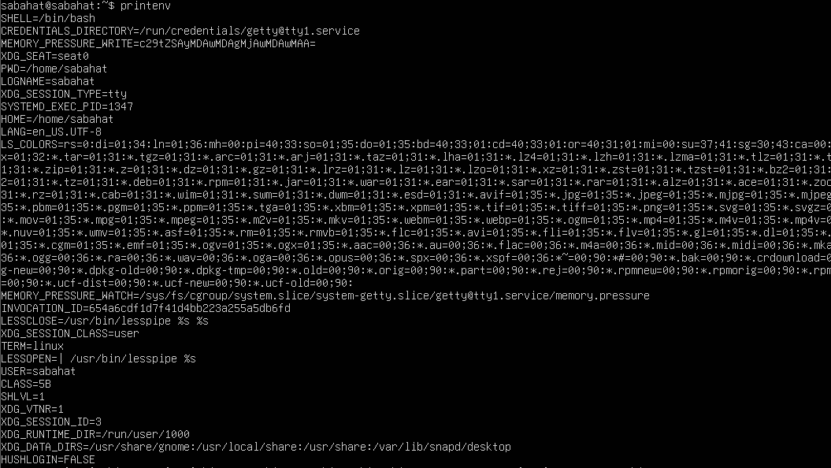
task1_printenv_all

task1_grep_shell_home_user
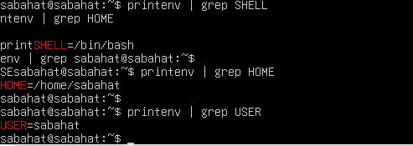
Task 2 – Create Temporary DB_* Environment Variables
task2_exports_all
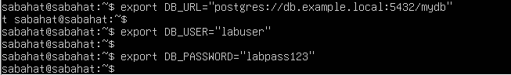
task2_echoes_all
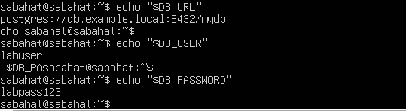

task2_printenv_grep_db
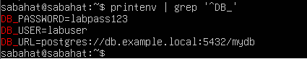
task2_after_restart_checks
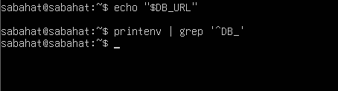
Task 3 – Make Variables Persistent Using ~/.bashrc
task3_bashrc_added
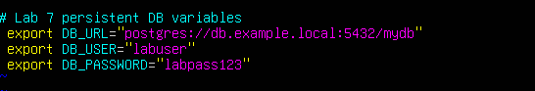
task3_source_and_verification
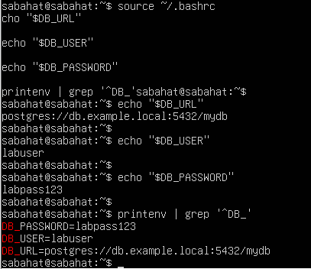
task3_after_restart_persistent
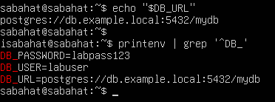
Task 4 – System-Wide Variable, PATH Update, and Welcome Script
task4_etc_environment_before
task4_echo_path_before
task4_etc_environment_edit_vim
task4_etc_environment_after
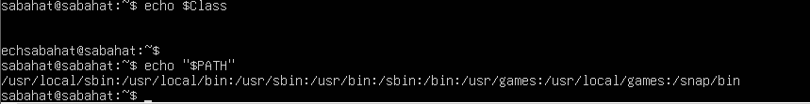
task4_echo_class_and_path
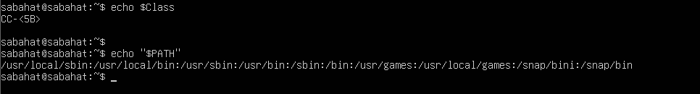
task4_welcome_create_and_chmod
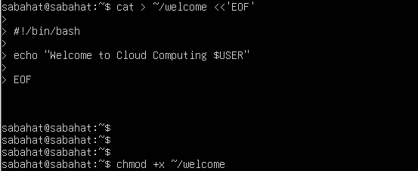
task4_welcome_run_dot

task4_bashrc_path_line
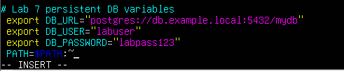
task4_bashrc_source_and_welcome
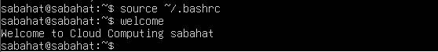
Task 5 – Block and Allow SSH Using UFW
task5_ufw_enable_and_status
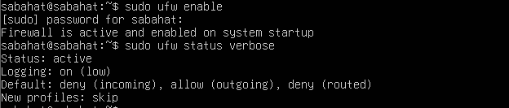
task5_ufw_deny_22_and_status
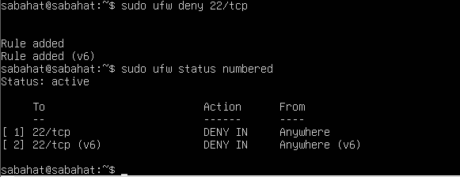
task5_ssh_attempt_blocked
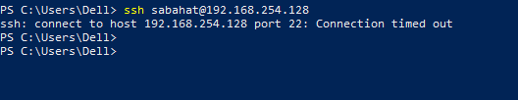

task5_ufw_allow_reload_status
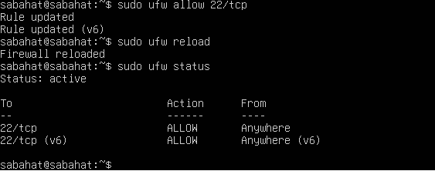

task5_ssh_success_after_allow
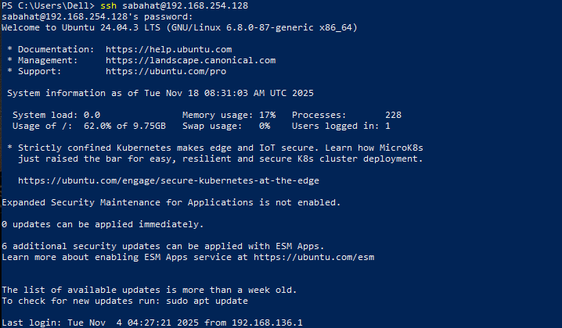

Task 6 – SSH Key-Based Authentication
task6_windows_sshkey_and_list
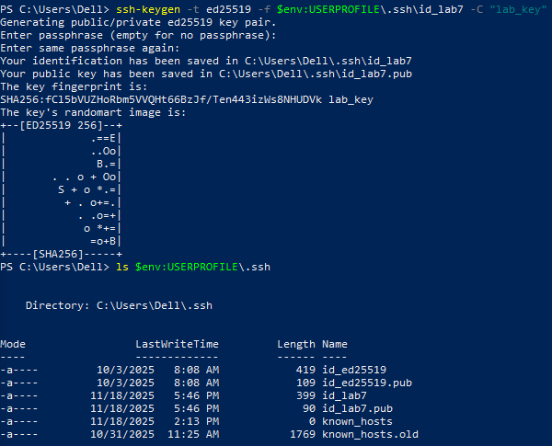
task6_windows_public_key
task6_windows_known_hosts_cleared_and_empty
task6_windows_ssh_accept_hostkey_and_login
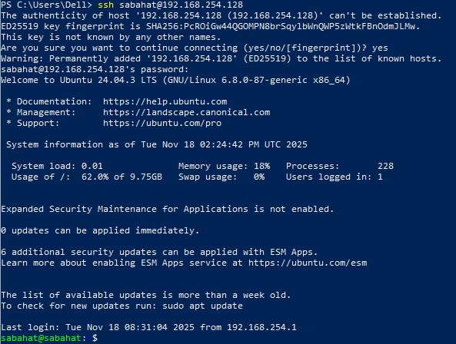
task6_windows_known_hosts_after_connect

task6_server_clear_authorized_keys
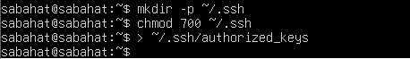
task6_server_add_key_and_show
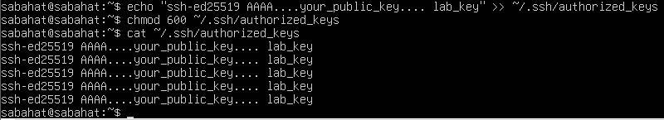
task6_ssh_passwordless_login
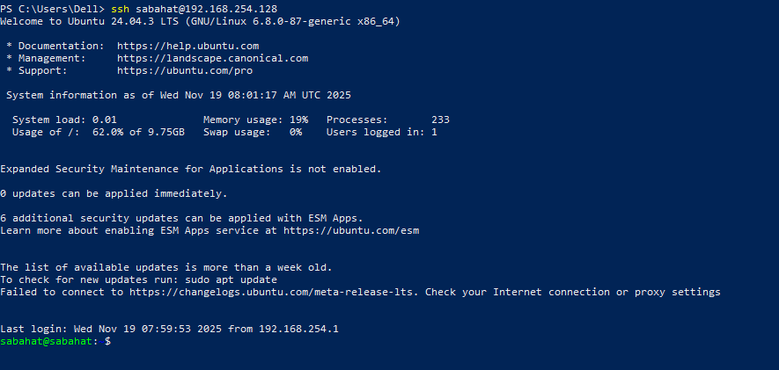

Exam Evaluation Questions
Q1: Quick Environment Audit
- Objective: Demonstrate you can inspect the current environment and extract a few key variables.
- Actions & evidence:
  - Run a single command to display environment variables and capture its output.
    - Save screenshot: EE_q1_env_all.png
EE_q1_env_all
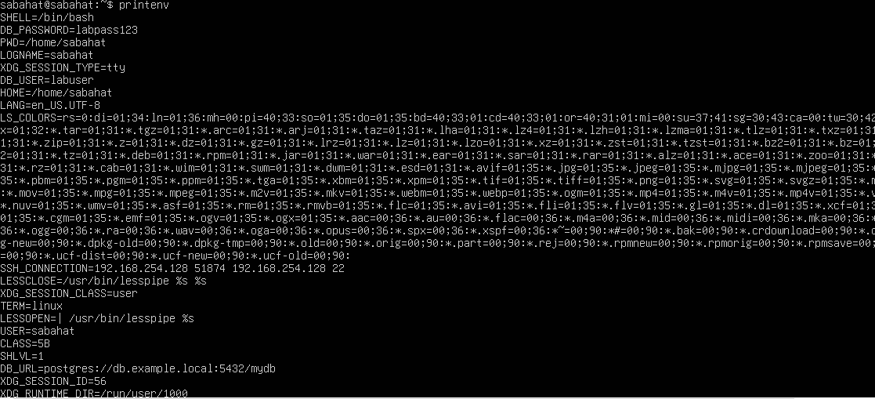
EE_q1_env_filters
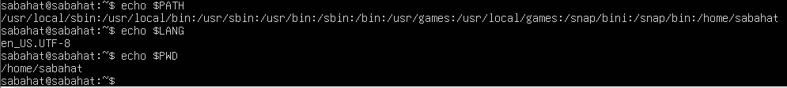
Q2: Short-lived Student Info
EE_q2_exports
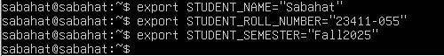
EE_q2_echoes
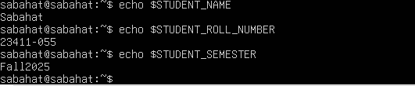
EE_q2_printenv_grep 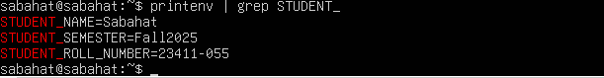
EE_q2_after_restart

Q3: Make It Sticky (Persistence Check for Student Info)
EE_q3_bashrc_editor
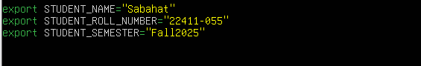
EE_q3_after_source

EE_q3_after_restart
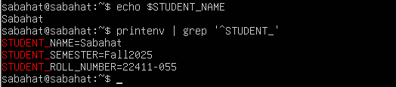
Q4: Firewall Rules: Block and Restore Ping (ICMP)
EE_q5_ufw_enable_status
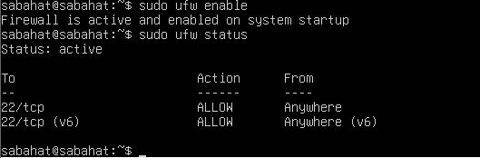
EE_q5_ufw_deny_ping_status
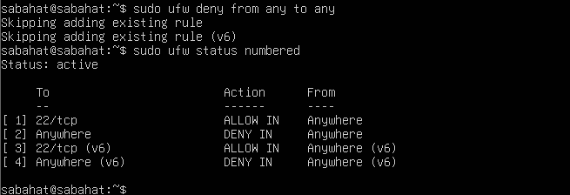
EE_q5_ping_blocked
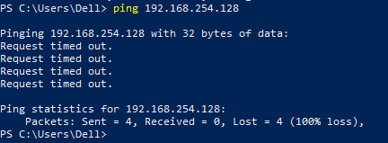
EE_q5_ufw_allow_ping_status
EE_q5_ping_success
